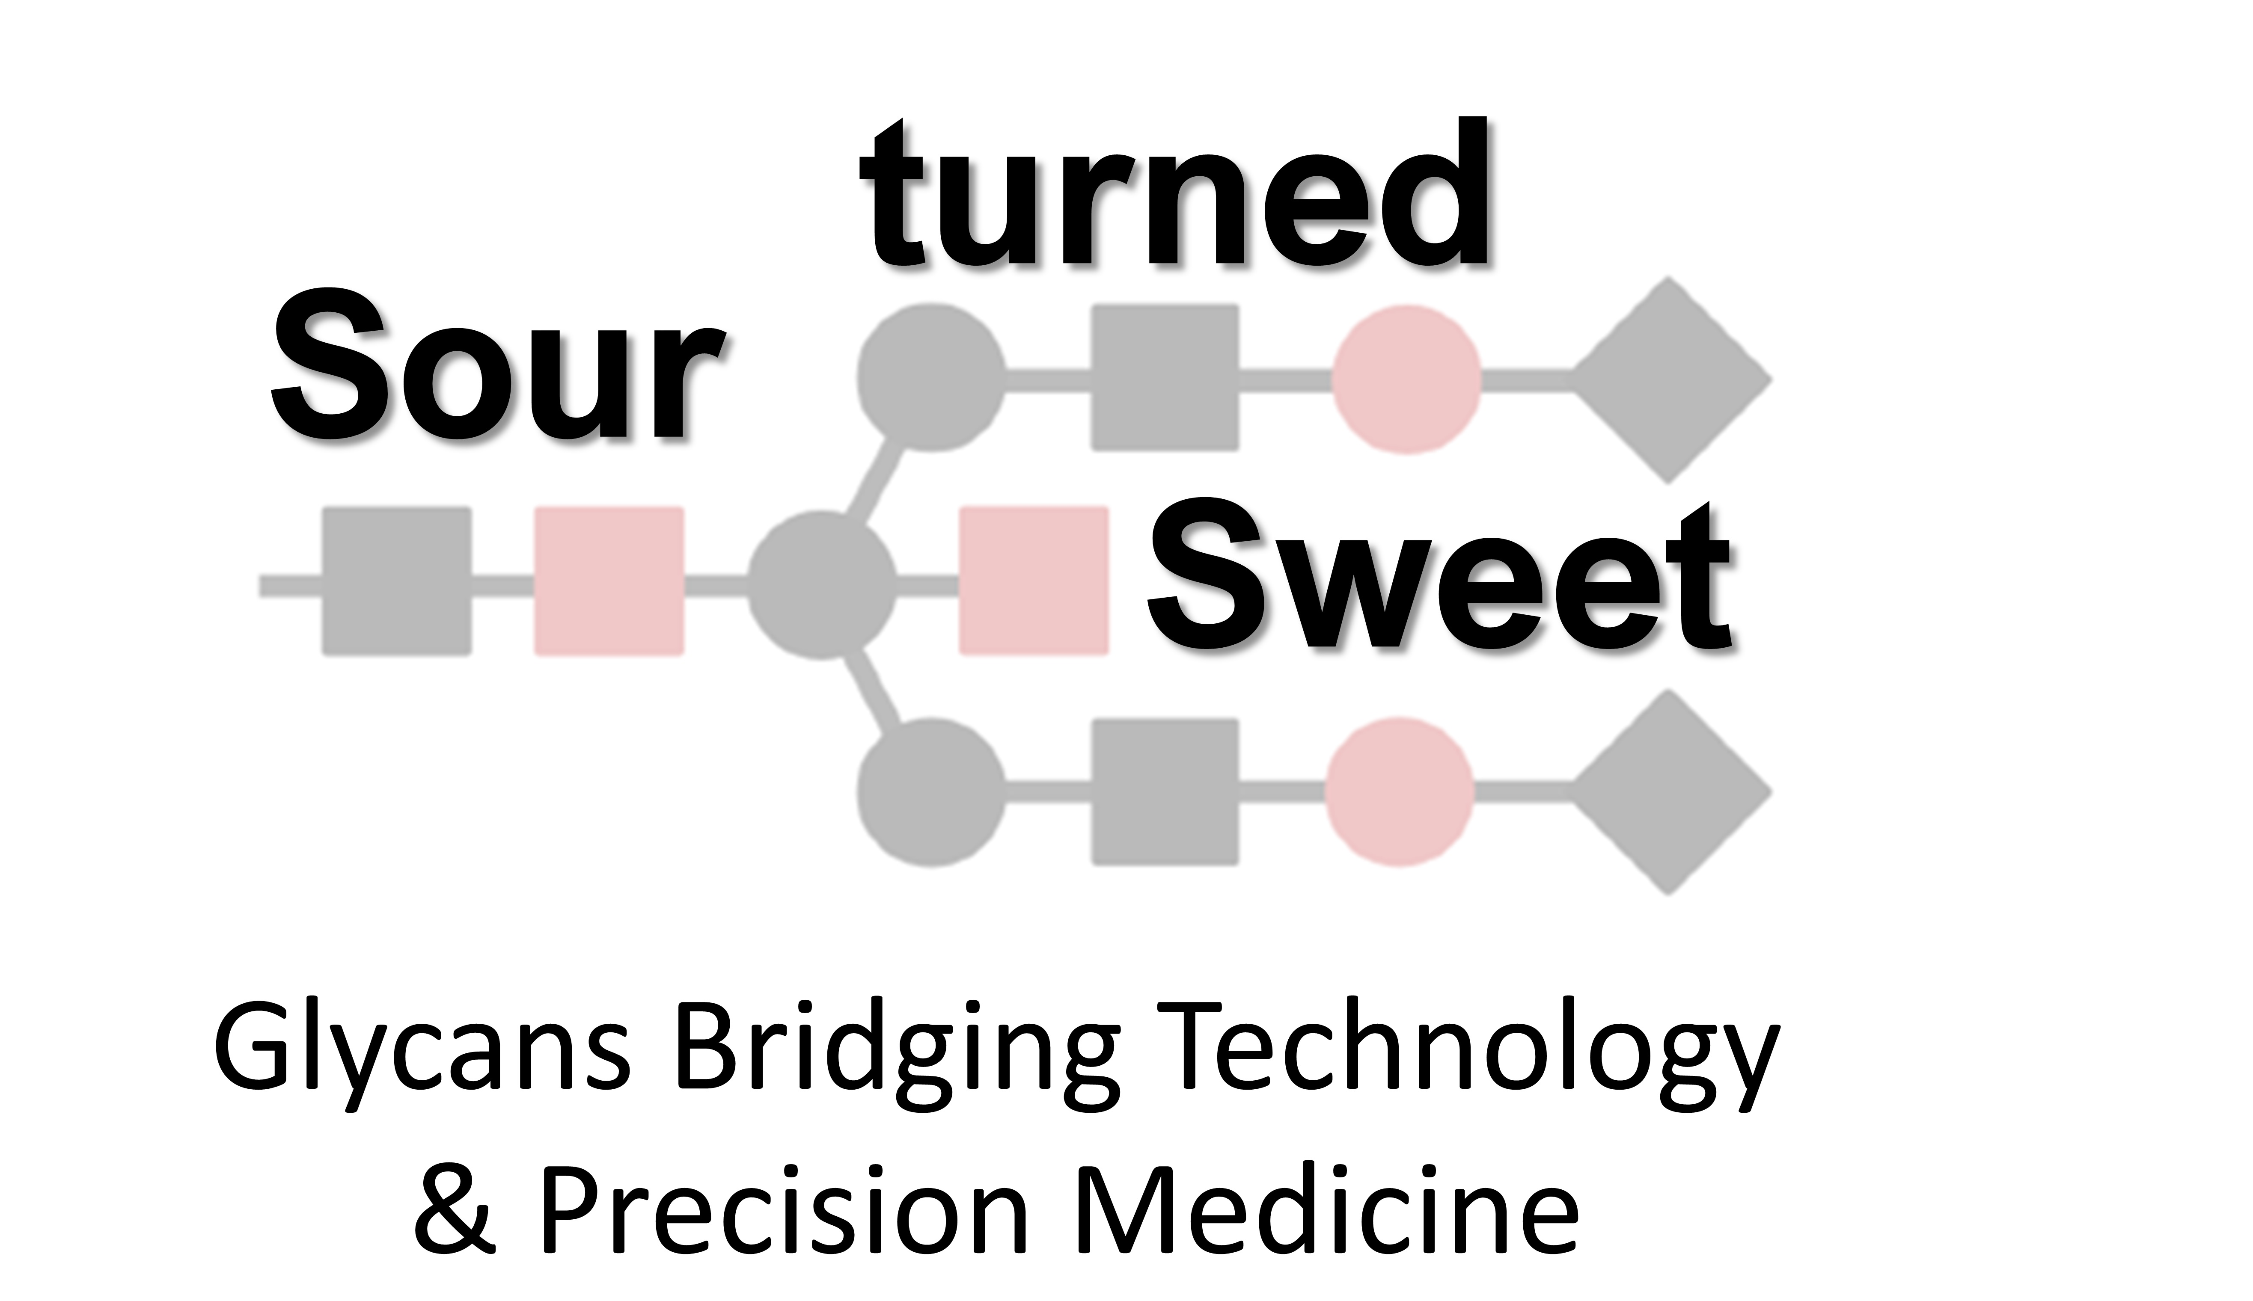 | 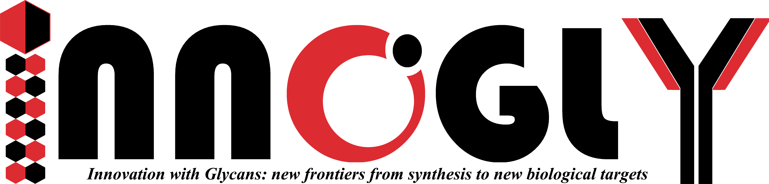
 | 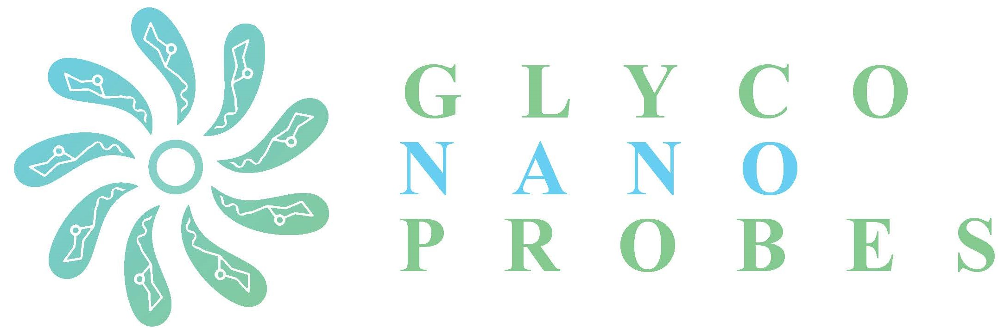

Young Researchers on stage: International Meeting of Young Researchers – INNOGLY & GLYCONanoPROBES
Iasi - Romania, 20th-21st April 2023

The COST Actions 18103 INNOGLY and 18132 GLYCONanoPROBES have joined efforts to organize the International Meeting of Young Researchers – INNOGLY & GLYCONanoPROBES, which will take place on the 20th-21st April 2023 at the Grigore T. Popa University of Medicine and Pharmacy in the historic and beautiful city of Iasi, Romania.
This international scientific meeting entitled “Sour Turned Sweet: Glycans Bridging Technology and Precision Medicine”, aims at providing an interactive forum in which young and early career researchers from both COST Actions can present and discuss their latest work and findings in a collaborative, engaging and multidisciplinary environment.
The organizing and scientific committee of this meeting composed of young researchers from both COST Actions prepared an engaging and diverse scientific program to foster fruitful discussion and boost collaborative networks.
The meeting will host two outstanding plenary speakers:
- Prof. Sandra van Vliet, principal investigator at the VU University Medical Center (Amsterdam, The Netherlands), focuses her research on the dissection of the signaling properties of glycan-binding receptors, using glycol engineered cell models of human malignancy; and
- Prof. Marko Anderluh, group leader at the Faculty of Pharmacy of the University of Ljubljana (Ljubljana, Slovenia), develops potent inhibitors of disease-related glycosylation machinery for the functional probing of pathophysiological interactions.
We hope that the International Meeting of Young Researchers – INNOGLY & GLYCONanoPROBES constitutes a unique opportunity for scientific discussion, networking and social interaction.
See you all in Iasi,

The Organizing Committee

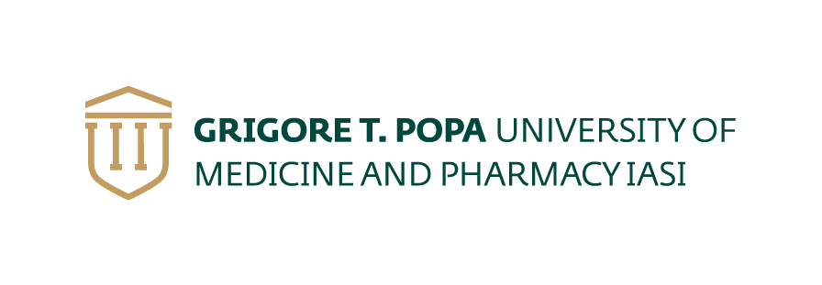 | 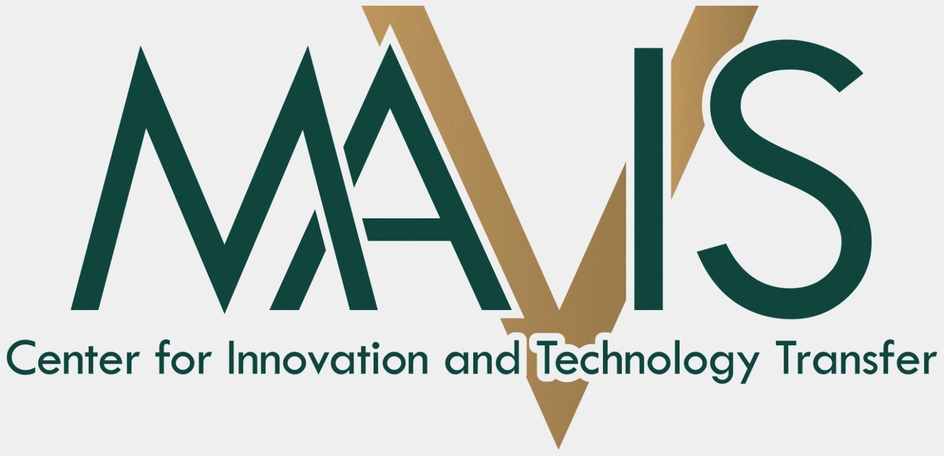 | 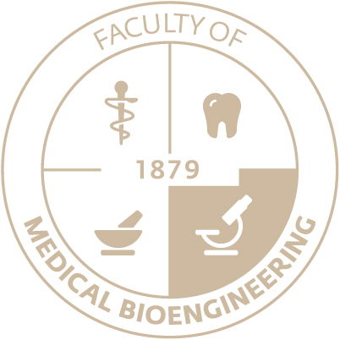 | 